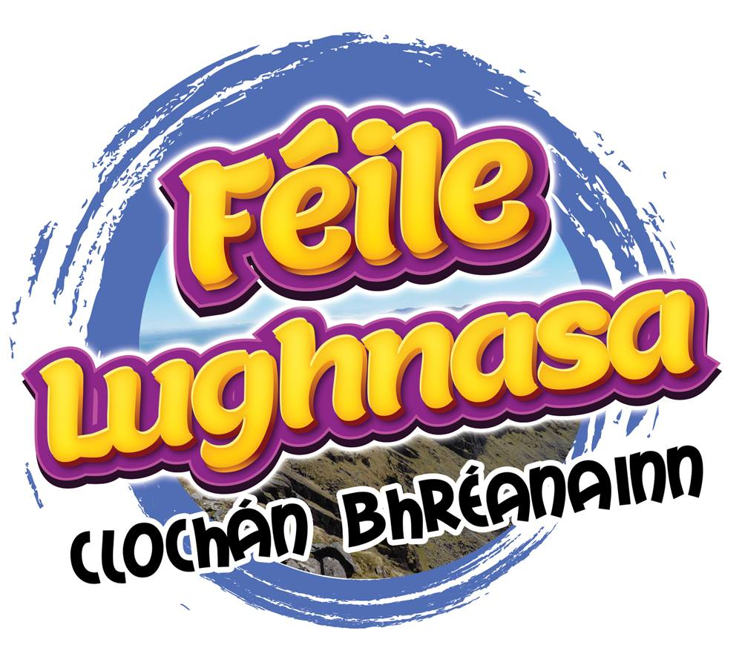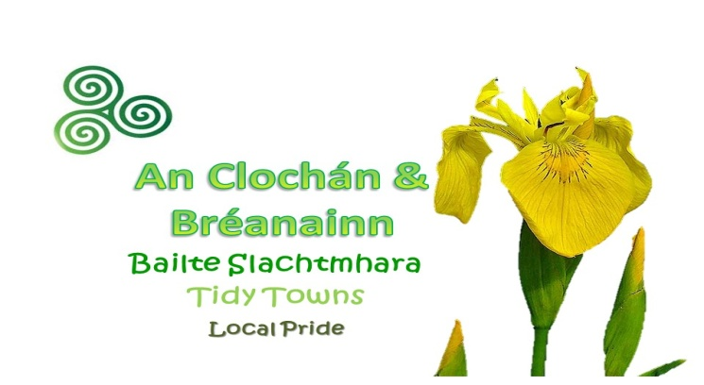
Féile Lughnasa 2022
Roadside Floral Display Competition
Online application only

Note : Adjudicators will not be entering peoples gardens therefore all entries must be visible from the roadside.
Name:
_____________________________________________
Eircode:
_____________________________________________
Display Type: ( identify whether it's a : flower bed, container, window box, hanging basket or other)
_________________________________________________________
Location of Display: ( to ensure adjudicators can find it)
________________________________________
Telephone number: ( mobile preferable)
_______________________________________
Email address: ( your email address)
_________________________________________
Email entry with photograph to: tidytownscb@gmail.com
Closing date: Monday July 25th 2002 @5pm
Remember to attach photograph along with application form i.e. 1 email) or copy and paste on to page 2

Please Copy and paste your photograph below
and submit with this online application:

Good Luck and Thank you for entering the competition:
Photographs here please:

