Just for Fun Quiz Round 2 Answers

- What county would you find Buncrana? Donegal

- What are the three saint statues in the Grotto in Faha? Saint Brendan, Saint Patrick and Our Lady

- Whose logo is this? Dingle Distrillery
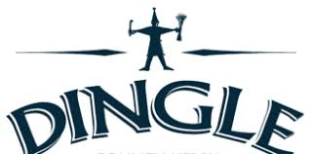

- What is the Irish word for rainbow? Bogha báistí

- What day of the week does the Grúpa Sugartha (Parent and Toddler) group meet in Halla Le Chéile? Thursday

- What was the name of the Hybrasel Play that took place in Féile Lughnasa 2019? Mikey Tatey Saves Arreglen

- What sport do you associate with Eoin Morgan? Cricket

- How many ladders are there on the Cé? 5

- What year was Siopa an Phobail opened? 2011

- What is ophidiophobia the fear of? The fear of snakes

